WashFold Orlando
Driver Procedures Manual
Pickup & Delivery Role — Step-by-Step Guide

1. Before You Start — Clock In
Every shift starts the same way, on your assigned station device or phone:
- Open the Driver app.
- Tap 🕐 Clock In on the header widget.
- If you're clocking in outside your scheduled shift window, you'll see a warning — confirm only if this is intentional (e.g. covering an extra shift).
- Once clocked in, you'll see a running elapsed-time pill confirming you're on the clock.
At the end of your shift, tap Clock Out the same way — don't leave the app open and walk away without clocking out.

2. Logging In (PIN Gate)
After clocking in, you'll be asked for your 4-digit PIN to unlock your queue.
- Enter your PIN exactly as given to you by your manager.
- If you get "PIN not recognised," you either mistyped it or your PIN isn't set up as an active Driver — contact your manager, don't guess.
- Owners/managers may see an "👑 Enter as Owner" option instead — this shows every order at the location, not just your assigned ones. Regular drivers won't see this.

3. Your Queue
Once you're in, you'll see your assigned orders split into two separate lists:
- Pickups — orders where you're the assigned pickup driver.
- Deliveries — orders where you're the assigned delivery driver.
These are independent — you might be on someone else's pickup list but not their delivery list, or vice versa. Only work orders that show up under your own name.
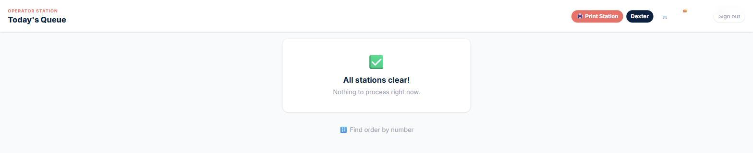
The queue home screen — when everything is done, it shows "All stations clear!" Your real queue lists your assigned stops here instead.

4. Starting Your Route
Before heading out, tap 🚗 Start Route — Notify All Customers.
- This automatically texts every customer on your route letting them know you're on the way.
- It's safe to tap once — the system won't double-text a customer if you tap it again by accident.

5. At the Customer's Door (Pickup)
For every pickup stop, you must complete both of the following before you can confirm the pickup — the Confirm button will not work until both are done:
- Take a photo at the customer's door showing the bag(s) collected.
- Select the correct color-key sticker for this pickup (see the Color-Key Legend in Section 8).
Once both are done, tap 📦 Confirm Pickup of [n] Bag(s). Double-check the bag count on screen matches what you actually picked up before confirming — this count is what gets reconciled against the customer's order.
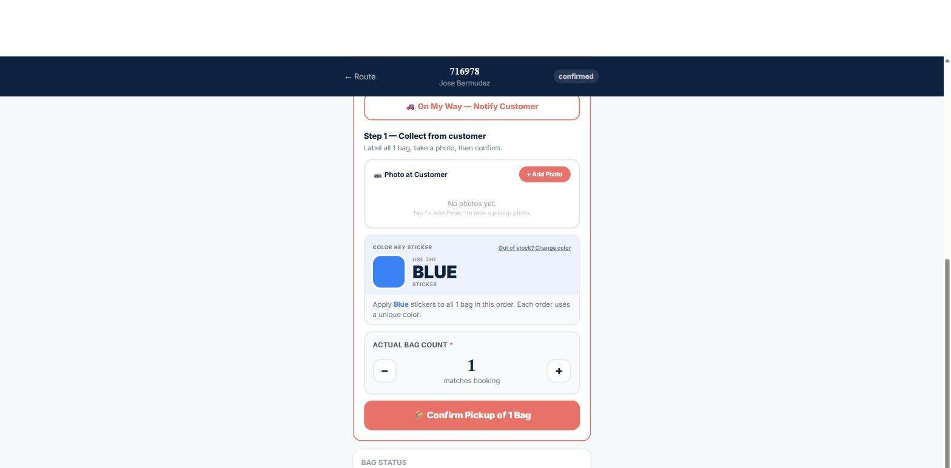
Real order screen: photo requirement, color-key sticker assignment, actual bag count, and the Confirm Pickup button — all from a live order.
⚠ IMPORTANT
The Confirm Pickup button is intentionally locked until you've taken the photo AND picked a color. This isn't a bug — it's there so no pickup gets logged without proof and a way to identify the bags later.

6. Facility / Warehouse Drop-off & Weigh-In
When you arrive at the facility or warehouse to drop off, you must complete both of the following before the Confirm Drop-off button unlocks:
- Take a placement photo showing where the bags were left at the facility/warehouse.
- Enter a weight for every bag. Weight must be greater than zero — the system will reject a blank, zero, or invalid number.
Once both are complete, tap 🏭 / 🏪 Confirm Drop-off · [total] lbs.
- Every order is billed at a 20 lb minimum, even if the actual weight comes in lower — this is normal and not something to "fix" by entering a fake higher weight.
- If a weight was already entered earlier by someone else on this order, the system will skip re-billing automatically — you don't need to worry about double-charging a customer.

7. Delivery
⚠ DELIVERY IS COMPLETED IN SHIPDAY, NOT THIS APP
There is no "Mark Delivered" button in the Driver app. This was removed on purpose after a past incident where two different systems both tried to mark the same order delivered and caused confusion.
Delivery completion is handled through the Shipday dispatch app instead. Always complete deliveries there, signed in under your own driver account (not a shared/owner login) — see the note below.
When you finish a delivery, mark it complete in the Shipday Drive app on your phone. Make sure you are logged into Shipday as your own driver profile — not the company/owner account — so the completion is correctly tied to your assigned order.

8. Color-Key Sticker Legend
Every bag gets a color sticker at pickup. Colors are assigned automatically per same-day order so bags from different customers picked up the same day don't get mixed up.
Color | Meaning
Red | Assigned automatically per same-day order to prevent bag mix-ups. No fixed meaning beyond same-day identification.
Blue | Assigned automatically per same-day order to prevent bag mix-ups. No fixed meaning beyond same-day identification.
Sky | Assigned automatically per same-day order to prevent bag mix-ups. No fixed meaning beyond same-day identification.
Green | Assigned automatically per same-day order to prevent bag mix-ups. No fixed meaning beyond same-day identification.
Lime | Assigned automatically per same-day order to prevent bag mix-ups. No fixed meaning beyond same-day identification.
Pink | Assigned automatically per same-day order to prevent bag mix-ups. No fixed meaning beyond same-day identification.
Hot Pink | Assigned automatically per same-day order to prevent bag mix-ups. No fixed meaning beyond same-day identification.
Orange | Assigned automatically per same-day order to prevent bag mix-ups. No fixed meaning beyond same-day identification.
Yellow | Reserved — means the bag has been sent to STORAGE, not a normal same-day order.
Purple | Assigned automatically per same-day order to prevent bag mix-ups. No fixed meaning beyond same-day identification.

If you physically run out of a color sticker mid-route, there is a way to swap to a different available color in the app rather than guessing or leaving a bag unmarked — ask your manager to show you this if you haven't used it before.

9. Quick Reference — Full Order Lifecycle
Here's the full journey an order takes, so you can see where your part fits in:
- Pending → Picked Up (you) → At Warehouse / At Facility → In Washer → In Dryer → Folded/Ready → Out for Delivery → Delivered (via Shipday)

10. End of Shift
- Confirm all your assigned pickups and drop-offs for the day are complete.
- Complete any deliveries in Shipday.
- Tap Clock Out in the app.

Questions about anything in this manual? Ask your manager before improvising — especially around weigh-ins, photos, and delivery confirmation, since those steps protect both you and the customer if there's ever a dispute.

